Part B: Nervous system function (17 marks)
Jenny had surgery to set her broken bone; this was done under general anaesthesia.
The unlabelled graph of the action potential phases has been provided to assist with your answers

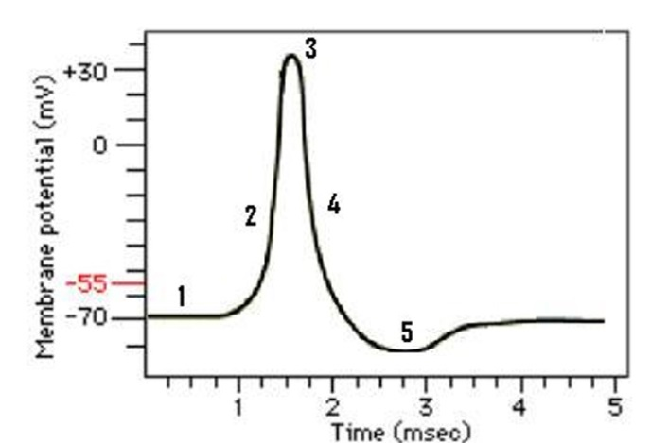

- When nerve cells are at rest, there is a resting membrane potential (RMP; phase #1 on graph) for the neuron cell membrane. Describe how the RMP is generated. (3 marks)

- Jenny is conscious and alert when certain neurons in her brain are active. Her neurons depolarise, produce action potentials, repolarise and hyperpolarise. Define depolarization and hyperpolarization and explain their relationship to threshold. (3 marks).

- Jenny’s nerve cell membranes have both leak (passive) potassium channels and voltage-gated potassium channels. Explain how these channels differ, in terms of where in the cell they are located and in how they work. (3 marks)

- Anaesthesia to be used for Jenny’s procedure will affect her neurons for consciousness and sensation of pain. The anaesthetic acts by opening more potassium leak (passive) channels. How does this make Jenny’s neurons less likely to produce the action potentials that would normally keep her awake and experience pain? (3 marks)

- Skeletal muscle has similar types of potassium leak (passive) channels that react with the general anaesthesia. What might be the effect on Jenny’s skeletal muscle contraction during surgery? Explain. (2 marks)

- Prior to surgery, Jenny’s pre-op blood testing revealed hyperkalaemia (indicated high levels of extracellular potassium. What effect would elevated extracellular potassium have on muscle and nerves cells? (3 marks)

Part C:General questions on Nervous System Function (6.5 marks)
1. In terms of nerve communication,
a. Why might a patient experience sensations of tingling and numbness in their lips/tongue/face/neck? Suggest possible steps in nerve transmission that may be affected (3 marks)

b. Suggest likely affected peripheral nerves that may cause paralysis in the face and mouth; Justify your choice. (3.5 marks)

